# Software Requirements

*Specification*

# Movie ticket management system

**Document ID:** ASP-CMS-SRS-01.doc

**Author(s): DHARUN M**

**Version:** 0.1

**Date:** January 25, 2023

**Confidential 1**



**Copyright notice:** Copyright © 1996-2004 Aspire Systems. All rights reserved. The contents on this document are not to be reproduced or duplicated in any form or kind, either in part or full, without written consent from Aspire Systems.

Contents

1. Objective and Scope 3
2. Features 3
   1. Login to the system 3
   2. Booking Tickets 4
   3. Admin 4
   4. Report 4
3. Diagrams 5
   1. Flow Diagram 5
   2. Use Case Diagram 6
   3. Class Diagram 7
4. PAYMENT 7
   1. ER - Diagram 8

￼

## Objective and Scope

The objective and the scope of the project is to build a Movie Ticket Booking that can deal with both the Theater Owners and the Customers to make Ticket booking easier way.

The scope of the product includes the following basic features:

* + User can book the tickets, and if ticket mistakenly booked and they can able to cancel the seats
  + User can book the cab
  + User can view the description of the movie
  + Privileged user updates the movies and seats
  + Admin can manage the overall system

## Features

### Login to the system

Each user should be authenticated with a User Name and Password to login into the system. Validations for User Name and Password.

New customers are directed to the Sign-up page to create their own credentials so the can login.

User Name: It accepts only Alphabets, Numbers, Dot (.) symbol and Underscore (_) symbol.

Password: It can be anything of the users’ choice. But it must not contain the username in the password, password should contain one special character, numbers, both upper-case and lower-case letters.

### Booking Tickets:

User can book their tickets and view their seats with different color and they can able to download the tickets, if user mistakenly book the seats they can cancel the ticket Privileged user

They can update the moves list and can update the seats if the customer book in the ticket counter, timing process of the movie, update the movie screen

### Admin

Privileged user verifying the update the review of the customer about movie, update the cancelled tickets of the privileged user. And to refund the payment. Admin can make overall changes

### Report

This system has reporting capabilities. It shows all the booking details.

## Diagrams

### Flow Diagram

### 

### Use Case Diagram

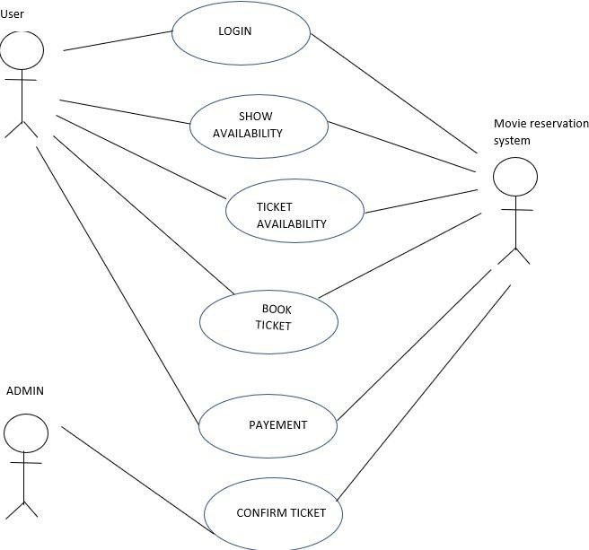

### 1.3 Class Diagram

### 

### 2.1 ER - Diagram

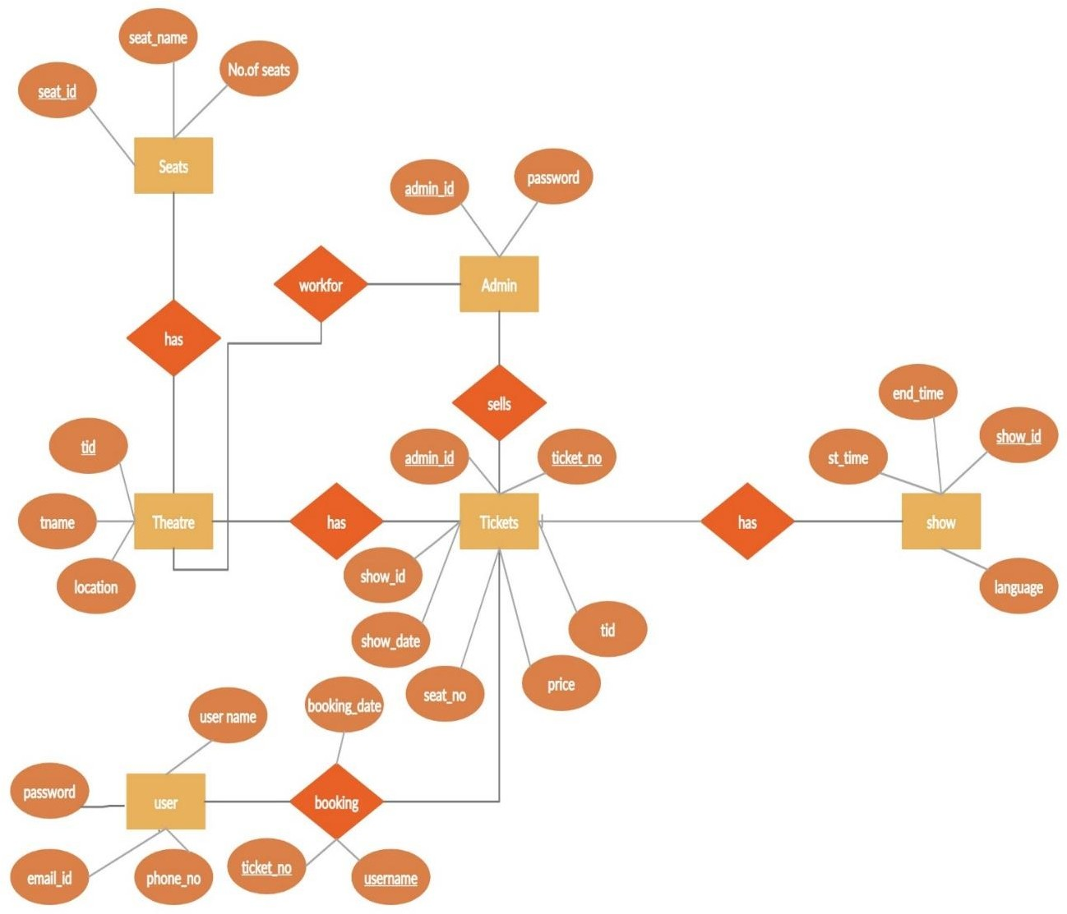

**2.2. Sequence diagram**

